CPSC 335 7/15/2021
- Minimum Selection Sort
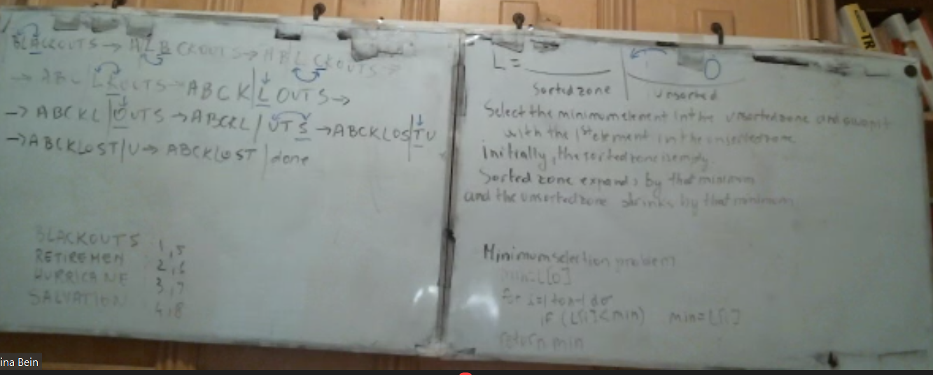
- We’re on Greedy Sort now
- Spanning Trees
  - https://discord.gg/J7xBw4w4

